ABC’s Inventory Management System

User Manual

Table of Contents

INTRODUCTION 3

What is the ABC Inventory Management App? 3

Learning Resources 4

Installation 4

System Requirements 4

For Windows OS 4

For Mac OS 4

Installing on Windows 4

Installing on a Mac 5

FIRST TIME LAUNCH 5

Sign In Account 5

OVERVIEW OF THE USER INTERFACE 7

Home Screen 7

Warehouse Staff 7

Store Staff 8

Search Product 9

Search Product code 9

Search Product Item code 10

View Product Item Location 11

Send Product Screen 12

Accept Product Screen 13

View Sending Transfers 13

View Transfer Detail 14

Manage Product Screen 15

Manage Product 15

Add New Product 16

Add New Product Item 17

# **INTRODUCTION**

## What is the ABC Inventory Management App?

The ABC Inventory Management App is the most convenient way to get detailed and precise information about the stock movement and stock theft. This would also allow employees to look up current stock contents of the warehouse and each store and then request stock as required. Employees will also be able to send stock digitally i.e. automatically make an update to the database when stock is sent. Moreover, distribution of stock would also be much easier for the warehouse staff as they will know the quantity of each stock for each store.

The ABC Inventory Management App for desktop has the following key features:

* The store (where goods are arriving):
  + All store staffs will be provided with a store staff login account for ABC’s Inventory Management Application.
  + The store staffs can login to the ABC’s Inventory Management Application in the store’s computer.
  + The store staffs can search products by the product code to check its information.
  + If the information shows that the quantity of that product is 0 or low in stock, the store staff might choose the desirable quantity of that product and send a request to the warehouse. They may add other products to the same request too if desired.
  + The store staff can log out the account for securing information.
  + Application can be used in different stores if the number of store increases in the future, database update would allow new stores to be a part of the system.
  + Store staff search the code of the received parcel containing requested stock.
  + If the details in the system about the contents of the items in the parcel matches the actual contents, store staff can accept the items in the system by clicking the accept button. This will update the database.
  + The store staff can check the report of the previous transactions
* The warehouse where (goods are leaving):
  + All warehouse staffs will be provided with a warehouse staff login account for ABC’s Inventory Management Application.
  + The warehouse staffs can login to the ABC’s Inventory Management Application in the warehouse computer.
  + The warehouse staffs can search the product by the product’s code to check its information.
  + The warehouse staff can add new products into the system.
  + The warehouse staff can also send parcel through the system by adding product code and quantity of each item in the parcel to be sent.
  + The warehouse staff can update the detailed information (except product code) in the system. Warehouse staff can also make changes to the number of stock available in both store and warehouse if stock discrepancies are found.
  + The warehouse staff can delete existing product that is no longer sold in the system.
  + The warehouse staff can check the report of the previous transactions.
  + The warehouse staff can add the new staff login account into the system.

# **Learning Resources**

ABC Developer Team provides help on how to use the ABC Inventory Management App for desktop. There’s the User Manual that you are reading now and an online support email: [abcsupportteam@gmail.com](mailto:abcsupportteam@gmail.com).

# **Installation**

## System Requirements

For using ABC Inventory Management System in your computer, please ensure that your computer meets the minimum system requirements for your operating system and hardware.

## For Windows OS

|  |  |
| --- | --- |
| **Component** | **Requirement** |
| Computer and processor | Minimum 1.6 GHz (or higher) (32-bit or 64-bit). |
| Memory | 2.0 GB RAM |
| Hard disk | 500MB of available disk space |
| Display | 1024 x 768 screen resolution |
| Graphics hardware | Minimum of 128 MB graphics memory |
| Operating system | Windows 10, Windows 8.1, Windows 8, or Windows 7 Service Pack 1 in 32-bit and 64-bit. For the best experience, use the latest version of any operating system. |

## For Mac OS

|  |  |
| --- | --- |
| **Component** | **Requirement** |
| Computer and processor | Minimum Intel processor, Core 2 Duo or higher |
| Memory | 2.0 GB RAM |
| Hard disk | 500MB of available disk space |
| Display | 1280 x 800 or higher resolution |
| Operating system | Mac OS X 10.11 El Capitan or later |

## Installing on Windows

The ABC Inventory Management App is installed by launching installer file that can be provided by ABC Developer Team.

1. Verify that your computer meets the minimum system requirements for your operating system and hardware.
2. After receiving the file from ABC Developer Team, you’ll see the installer file. Double-click on it (it should be called, ‘ABCInventoryManagement.exe’). That will launch the Install Wizard which will guide you through the installation process.

## Installing on a Mac

The ABC Inventory Management App is installed by launching the installer file that can be provided by ABC Developer Team.

1. Verify that your computer meets the minimum system requirements for your operating system and hardware.
2. After receiving the file from ABC Developer Team, you’ll see the installer file, “ABCInventoryManagement.dmg”.
3. Double-click on the downloaded file to create the ABCInventoryManagement-Macinstaller package on your desktop. You will see a progress bar dialog indicating the extraction process. When complete, you may see a new removeable media icon on that will look similar to the image on the left.
4. If necessary, double-click on the ABCInventoryManagement-Macinstaller icon on your desktop to open a window containing the installer package.
5. Double-Click on the AbcInventoryManagement.pkg icon in the window that resembles a box. This will launch the Install Wizard which will guide you through the installation process.

*Figure 1: MacOS Installation*

# **FIRST TIME LAUNCH**

## Sign In Account

Launch the ABC Inventory Management App for desktop by double-clicking on the ABC Inventory Management App icon found on your Windows desktop or in the Applications folder on your Mac.

The account will be provided by the warehouse staff, depend on the working location, staff will have an appropriate account, enter username and password into the appropriate boxes and then click the **SIGN IN** button. The **CLEAR** button is used for reset the text boxes to be blank.

If staff has forgotten your password, they need to contact with the warehouse staff as soon as possible to reset the password.

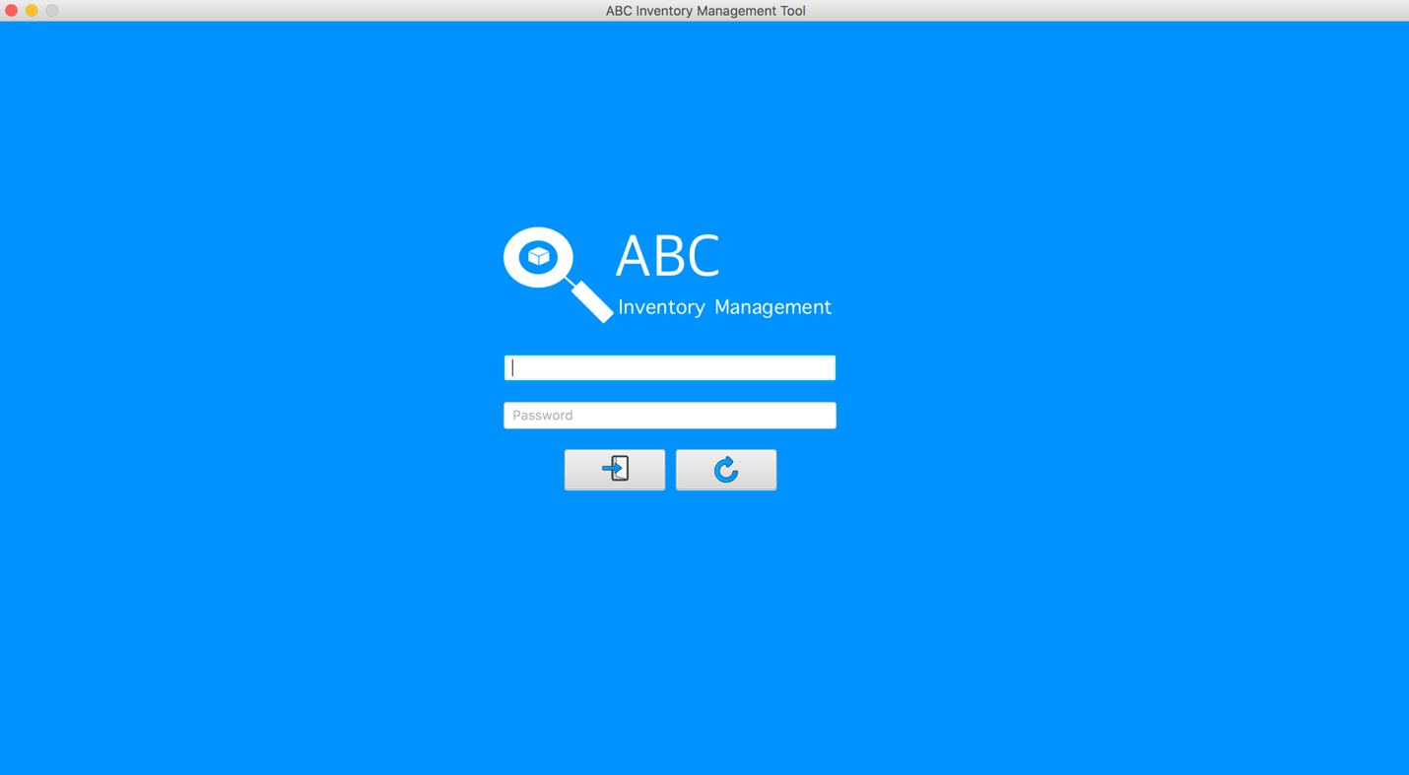

Sign In Button

Password

Username

Clear Button

*Figure 2: Login Interface*

# **OVERVIEW OF THE USER INTERFACE**

## Home Screen

### Warehouse Staff

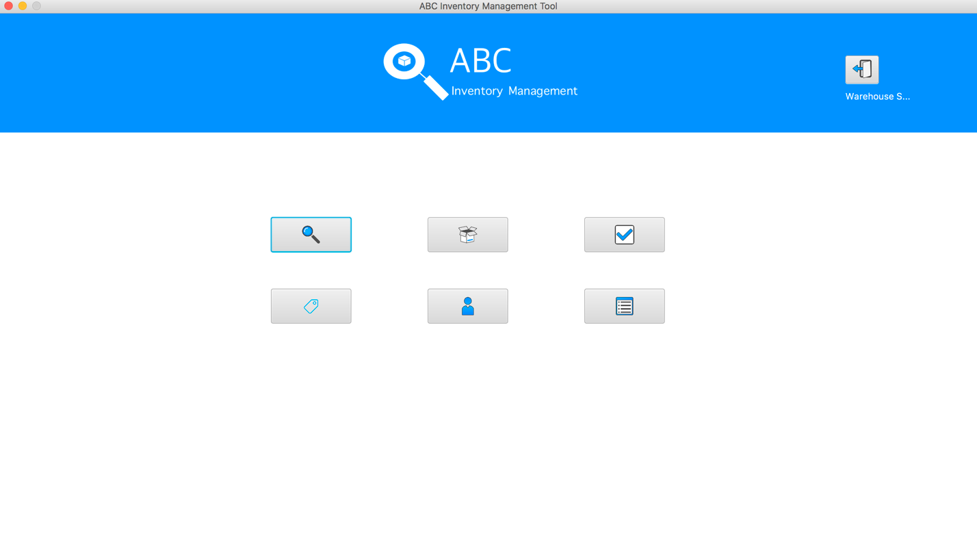*Figure 3: Warehouse staff Interface*

1

7

6

5

4

3

2

After logged in by the warehouse staff account, the application displays a home screen for user with 7 main functions as Figure 3:

1. Log out: located on the top-right corner in the screen, when user clicks on this button, the system logs out the current account and display the log in screen for signing in by other account. It also displays the role of current staff by the label under this button.
2. Search Product: users use this to search the details about the desired product in different locations by entering product code.
3. Send Product: this function is used for sending items from the location to another location indicating a delivery has been prompted.
4. Accept Product: this function is used for accepting the items that have been sent from another location indicating delivery has been accepted and database is updated.
5. Manage product: this function is used for add new products or product items, edit their detail information (quantity, description, name, etc. except product code) and remove products from the system.
6. Manage staff: this function is used for add and delete staff information including username and password.
7. Generate report: this function is used for generate a brief report containing sent location, destination location, delivery details (which consists the content details) when there is stock movement between two locations and filter the reports by in a specific timeframe.

### Store Staff

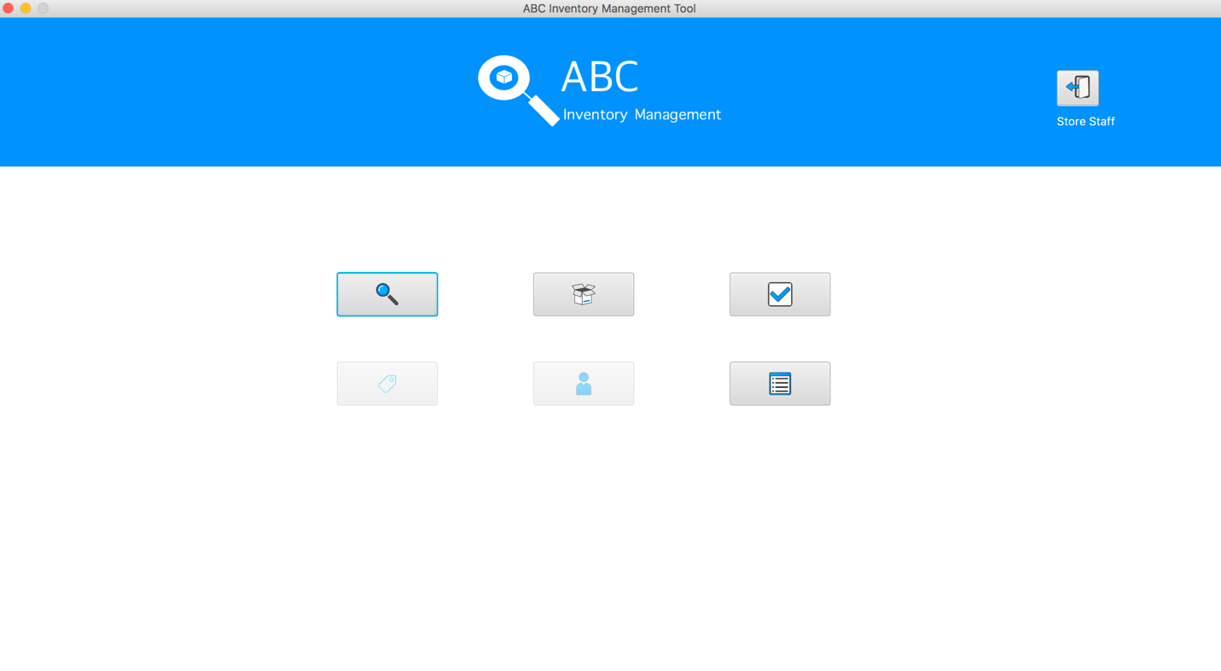*Figure 4: Store staff Interface*

5

2

3

4

1

After logged in by the store staff account, the application displays a home screen for user with only 5 main functions instead of 7 functions in Warehouse Staff home interface as Figure 4:

1. Log out: located on the top-right corner in the screen, when user clicks on this button, the system logs out the current account and display the log in screen for signing in by other account.
2. Search Product: users use this to search the details about the desired product in different locations by entering product code.
3. Send Product: this function is used for sending items from the location to another location indicating a delivery has been prompted.
4. Accept Product: this function is used for accepting the items that have been sent from another location indicating delivery has been accepted and database is updated.
5. Generate report: this function is used for generate a brief report containing sent location, destination location, delivery details (which consists the content details) when there is stock movement between two locations and filter the reports by in a specific timeframe.

## Search Product

### Search Product code

*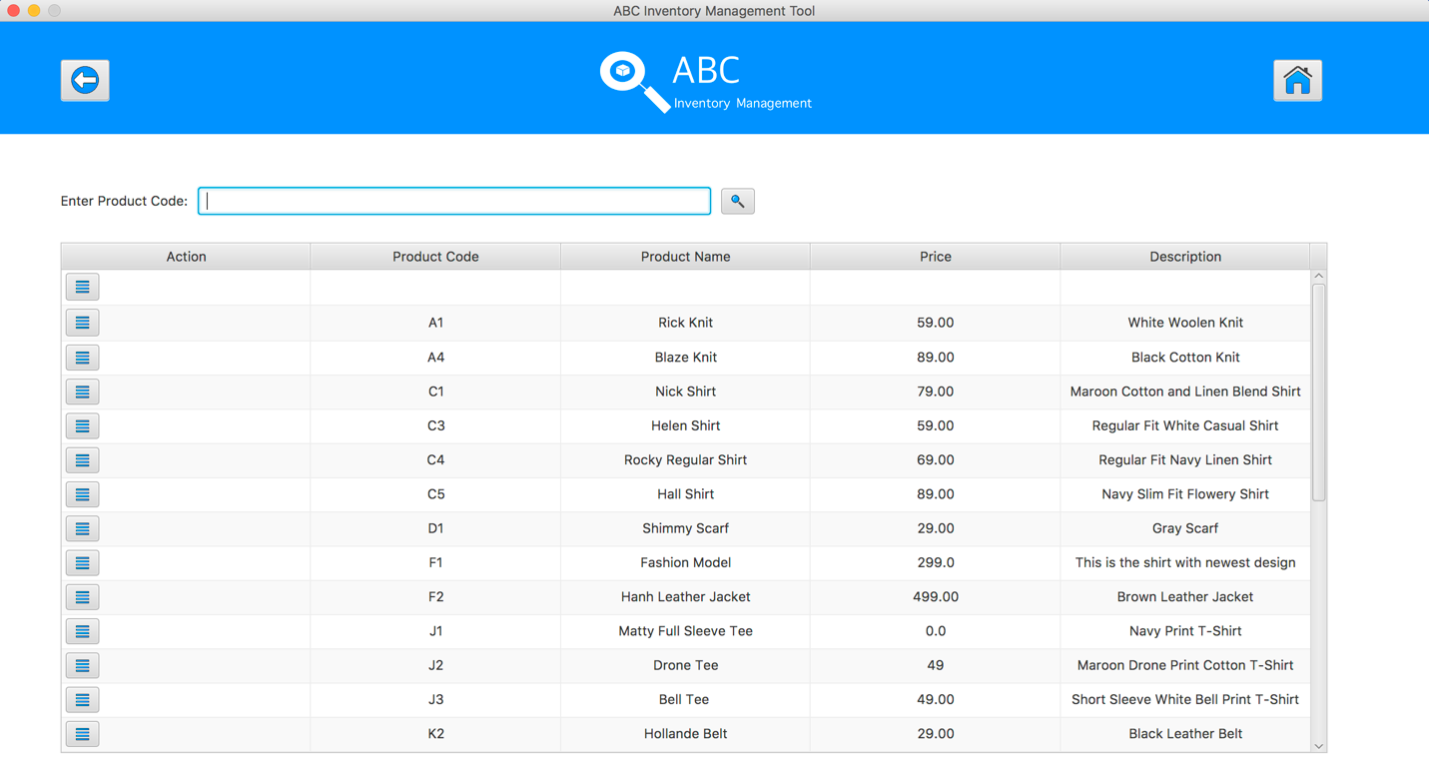Figure 4: Search Product Interface*

6

5

4

3

2

1

After selected Search Product Button from the home screen, system shows the Search Product Interface as can be seen in Figure 4:

1. Back Button: Go back to the home screen.
2. Home button: Go back to the home screen.
3. Product Code Text Field: User enters the desirable product code in this text field for searching a product.
4. Search button: After entered the product code in the text field, user hits enter keyboard or clicks on to this button to search a product.
5. “Detail” button: because 1 product contains different kind of product items (size s, m, xl, etc.) so user clicks on this button to see its product items.
6. Product information: This is the information of the product which includes product code, product name, price and description.

### Search Product Item code

*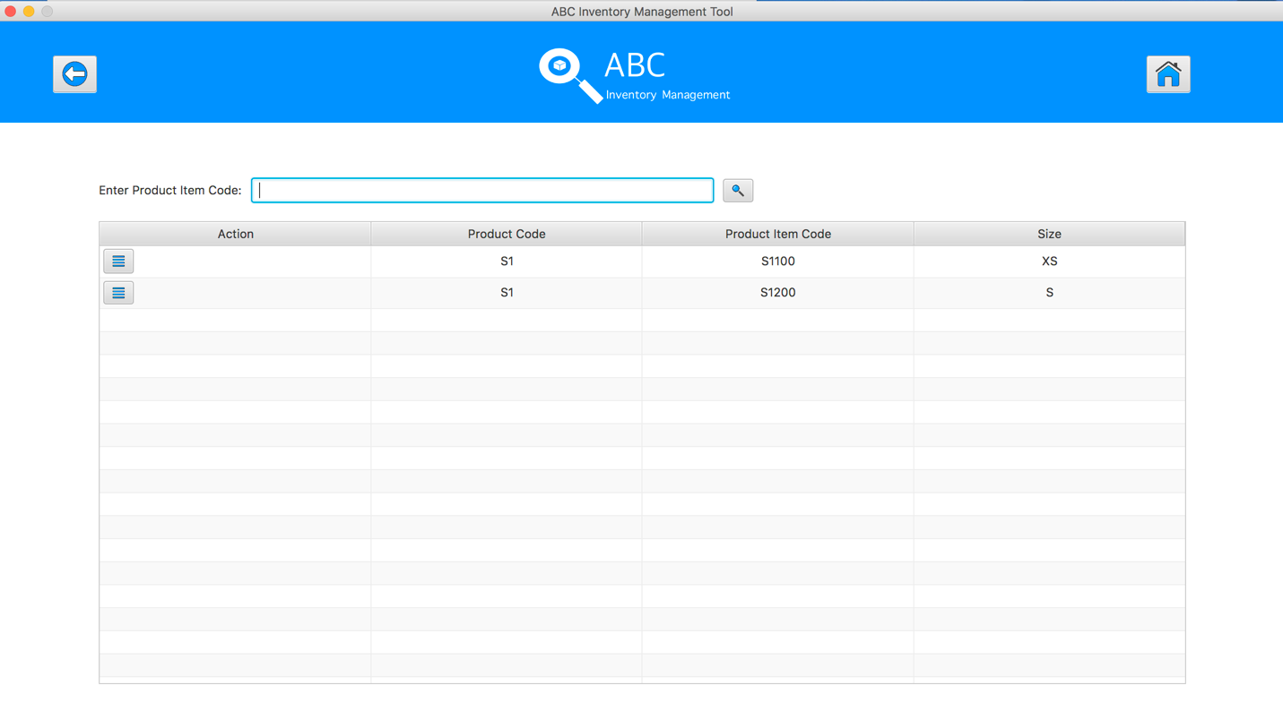Figure 5: Search Product Item Interface*

5

4

3

6

2

1

After hit the “Detail” button for a specific product, system shows the Search Product Item Interface which displays a list of product items in the selected product as can be seen in Figure 5:

1. Back Button: Go back to the Search Product screen.
2. Home button: Go back to the home screen.
3. Product Item Code Text Field: User enters the desirable product item code in this text field for searching a product item.
4. Search button: After entered the product item code in the text field, user hits enter keyboard or clicks on to this button to search a product item.
5. “Detail” button: because 1 product item can be stored in different locations so after hit this button, it shows the locations of this product item.
6. Product item information: This is the information of the product item which includes product code, product item code and size.

### View Product Item Location

*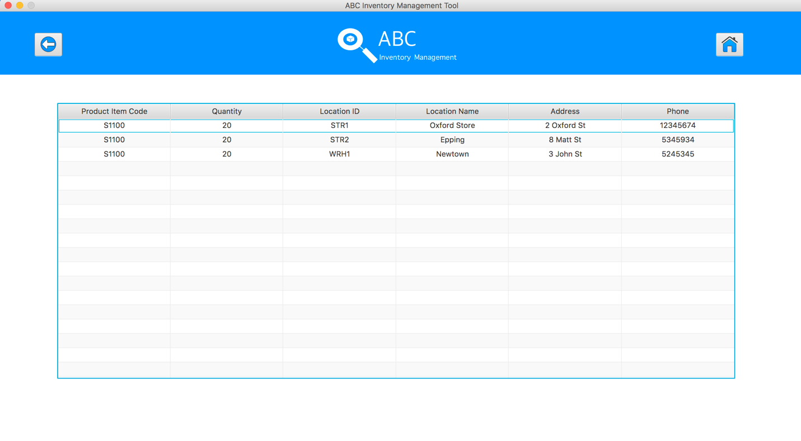Figure 6: View Product Item Location Interface*

3

2

1

After hit the “Detail” button for a specific product item, system shows the View Product Item Location Interface which displays a list of product items and the locations where store this product item as can be seen in Figure 6:

1. Back Button: Go back to the Search Product Item screen.
2. Home button: Go back to the home screen.
3. Product item information: This is the information of the product item which shows the location details of this product item.

## Send Product Screen

*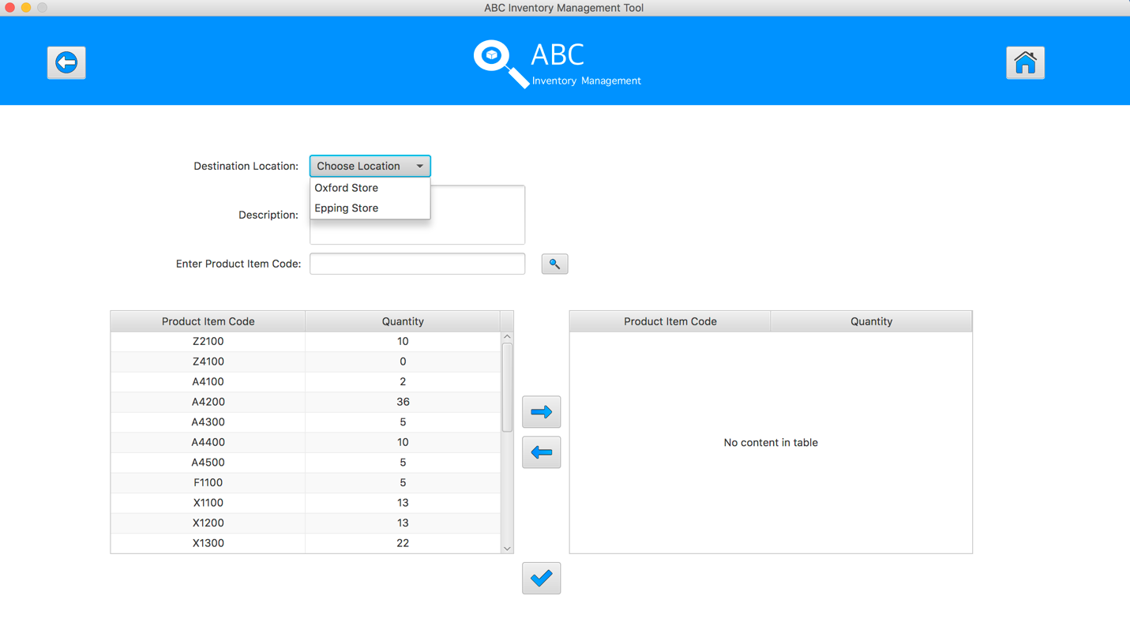Figure 7: Send Product Interface*

11

10

9

8

7

5

6

4

3

1

2

After selected Send Product Button from the home screen, system shows the Send Product Interface as can be seen in Figure 7:

1. Back Button: Go back to the Home screen.
2. Home button: Go back to the home screen.
3. Destination Location Dropbox: Staff selects the destination where the product will be sent from this drop-box list.
4. Description Text Area: Staff inputs the description for this transfer by typing in this box.
5. Product Code Text Field: Staff enters the desirable product code in this text field for searching a product in current location.
6. Search button: After entered the product code in the text field, user hits enter keyboard or clicks on to this button to search a product in current location.
7. Current product table: List of products and its quantity in current location.
8. Add to cart button: add the product from current product table to cart table for sending the product.
9. Remove from cart button: remove the selected product from the cart the table.
10. Cart table: the products which are added to this table will be the products for sending.
11. Send Product button: after hit this button, all the products will be sent to the destination, the quantity of the products which were sent in current location will be reduced appropriately.

## Accept Product Screen

### View Sending Transfers

*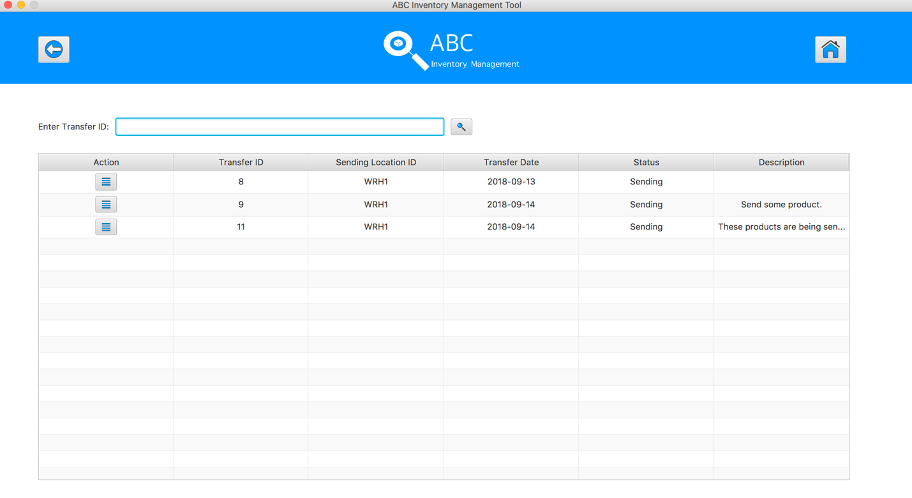Figure 8: View Sending Transfers Interface*

6

5

3

4

1

2

After selected Accept Product Button from the home screen, system shows the View Sending Transfer Interface as can be seen in Figure 8:

1. Back Button: Go back to the Home screen.
2. Home button: Go back to the Home screen.
3. Transfer ID Text Field: Staff enters the desirable transfer ID in this text field for searching a sending transfer.
4. Search button: After entered the transfer ID in the text field, user hits enter keyboard or clicks on to this button to search the desirable transfer.
5. Detail button: View the products which were sent in a specific transfer.
6. Transfer information: this part to show the information of transfers such as transfer id, sending location id, transfer date, status, description.

### View Transfer Detail

*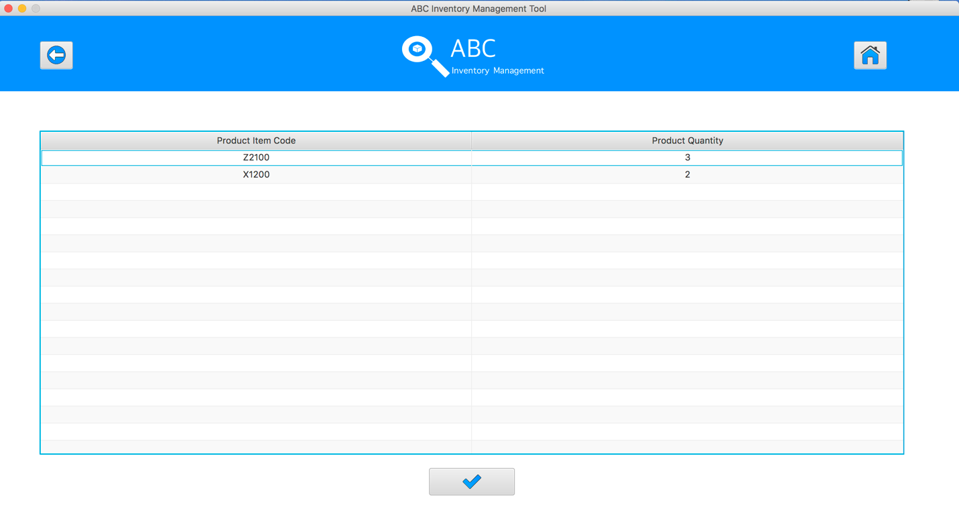Figure 9: View Transfer Detail Interface*

4

3

1

2

After selected Detail Button of a specific transfer, system shows the View Transfer Detail Interface which displays the products in this transfer as can be seen in Figure 9:

1. Back Button: Go back to the View Sending Transfer screen.
2. Home button: Go back to the Home screen.
3. Transfer Detail: this part shows the products information such as product item code and product quantity which were sent in this transfer
4. Accept button: after hit this button, system remove this transfer from the accept transfer list and change its status to be ”Accepted”, the quantity of those products what were accepted will be added to the accepted location.

## Manage Product Screen

### Manage Product

*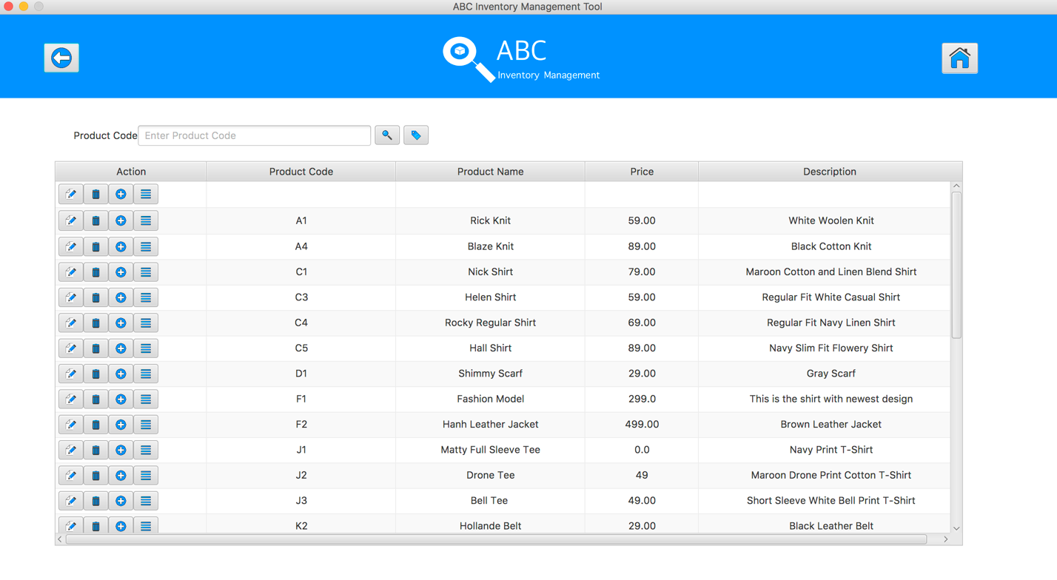Figure 10: Manage Product Interface*

7

5

4

3

6

1

2

After selected Manage Product Button from the home screen, system shows the Manage Product Interface as can be seen in Figure 10:

1. Back Button: Go back to the Home screen.
2. Home button: Go back to the Home screen.
3. Product Code Text Field: Staff enters the desirable product code in this text field for searching a product.
4. Search button: After entered the product code in the text field, user hits enter keyboard or clicks on to this button to search a product.
5. Add New Product button: after this button was pressed, system display the Add New Product interface to add a new product.
6. Action buttons: there are 4 buttons for each product with 4 functions: edit product information, delete product, add product items and view product items of specific product.
7. Transfer information: this part to show the information of transfers such as transfer id, sending location Product information: This is the information of the product which includes product code, product name, price and description.

### Add New Product

*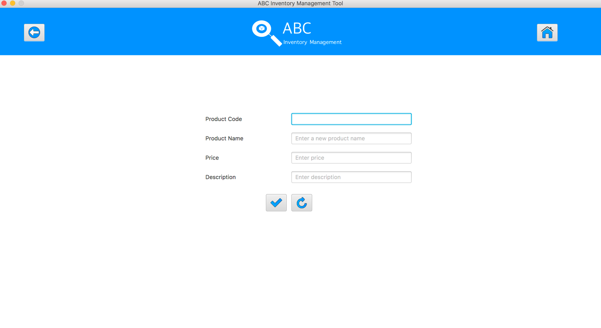Figure 11: Add New Product Interface*

8

7

6

5

4

3

1

2

After pressed Add New Product Button from the Manage Product screen, system shows the Add New Product Interface as can be seen in Figure 11:

1. Back Button: Go back to the Manage Product screen.
2. Home button: Go back to the Home screen.
3. Product Code Text Field: staff enters the new product code, the product code should be in the right format such as “S1”
4. Product Name Test Field: staff enters the product name for this new product.
5. Price Text Field: staff enters the price for this new product.
6. Description Text Field: staff enters the description about this new product.
7. Add Product Button: after filling all the new product information, staff clicks on this button to add this new product into the database.
8. Reset button: set all the text fields to be blank.

### Add New Product Item

*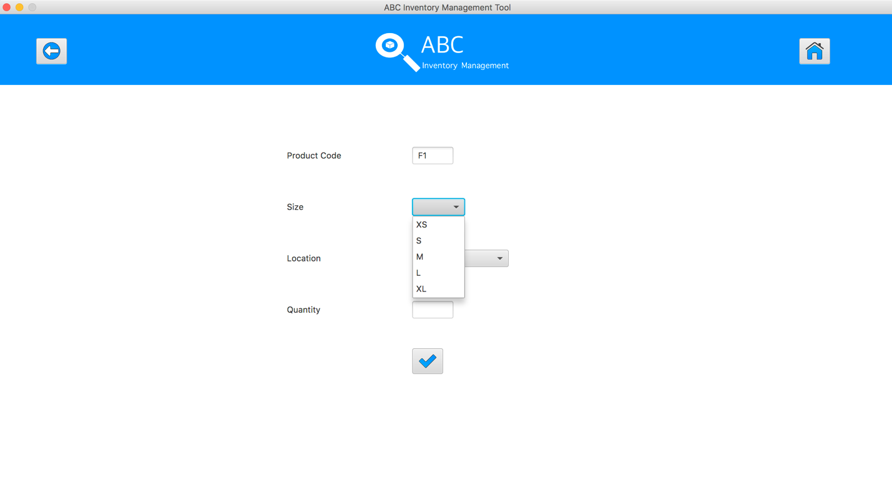Figure 12: Add New Product Item Interface*

6

5

4

3

7

1

2

After pressed Add New Product Item Button from the Manage Product screen, system shows the Add New Product Item Interface as can be seen in Figure 12:

1. Back Button: Go back to the Manage Product screen.
2. Home button: Go back to the Home screen.
3. Product Code Text Field: this text is set as the non-editable text field, so staff cannot edit this text field, it is used to let user know for which product they are they are adding the new product items.
4. Size Drop List: staff chooses the size for the new product item by selecting the size from this box. The new product item code will be generated base on selected size.
5. Location Drop List: staff chooses the location which stores this new product item.
6. Quantity: staff enters the number of quantity for this new product item.
7. Add Product Button: after filling all the new product item information, staff clicks on this button to add this new product item into the database.

### Edit Product Information

*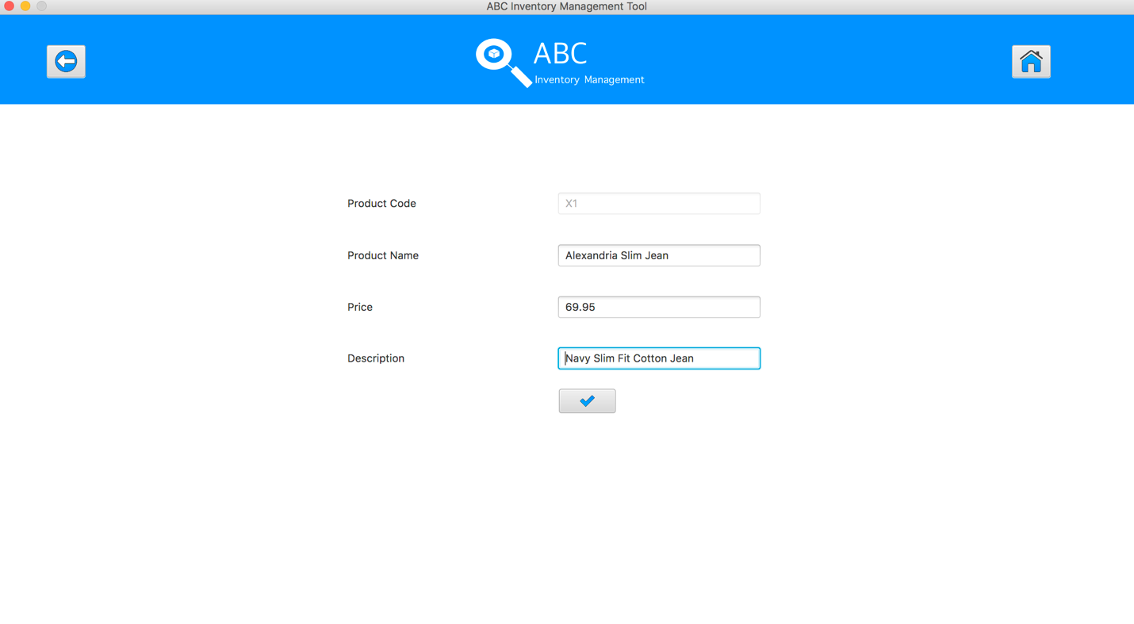Figure 13: Edit Product Information Interface*

7

6

5

4

3

1

2

After pressed Edit Product Button from the Manage Product screen, system shows Edit Product Information Interface as can be seen in Figure 13:

1. Back Button: Go back to the Manage Product screen.
2. Home button: Go back to the Home screen.
3. Product Code Text Field: this text is set as the non-editable text field, so staff cannot edit this text field, it is used to let user know for which product they are they are adding the new product items.
4. Size Drop List: staff chooses the size for the new product item by selecting the size from this box. The new product item code will be generated base on selected size.
5. Location Drop List: staff chooses the location which stores this new product item.
6. Quantity: staff enters the number of quantity for this new product item.
7. Add Product Button: after filling all the new product item information, staff clicks on this button to add this new product item into the database.